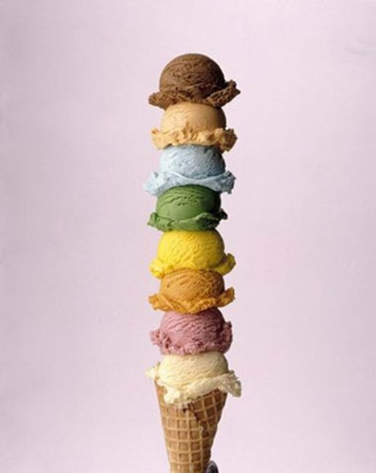**Ice Cream balls**

An ice cream cone contains three balls. Find the relation between the volumes of the ice cream balls X, Y and Z.

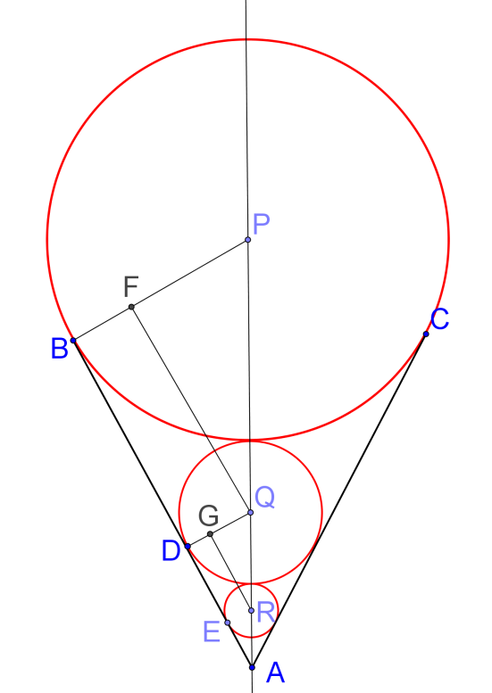As in the figure, P, Q and R are the centers of the ice cream balls.

B, D and E are the points of contacts of the balls with the side of the cone.

Let the radii of the balls be a = BP, b = DQ, c = ER

Draw : QF ⊥ BP , RG ⊥ DQ .

Note that BA // GR // FQ and BP // DQ // ER .

Then $∆PQF \sim ∆QRG$ (AAA).

$\frac{PQ}{PF}=\frac{QR}{QG}$ (sides of similar Δs in ratio)

$\frac{a+b}{a-b}=\frac{b+c}{b-c}$

$\left(a+b\right)\left(b-c\right)=\left(b+c\right)\left(a-b\right)$

$a b-a c+b^{2}-b c=a b+a c-b^{2}-b c$

${2b}^{2}=2ac$

$b^{2}=ac$

${\left(b^{2}\right)}^{3}={\left(ac\right)}^{3}$

$\left(b^{3}\right)\left(b^{3}\right)=\left(a^{3}\right)\left(c^{3}\right)$

$\left({\frac{4}{3}πb}^{3}\right)\left(\frac{4}{3}πb^{3}\right)=\left({\frac{4}{3}πa}^{3}\right)\left(\frac{4}{3}πc^{3}\right)$

Since X, Y and Z are the volumes of the balls, (X > Y > Z) we have the relation: $Y^{2}=XZ$

**Yue Kwok Choy**

**10/9/2015**